Lecture 26, November 18, 2010 (Key Points)

STATISTICAL VARIABILITY IN SPACE-TIME RAINFALL AND ITS
PHYSICAL ORIGINS

It is widely observed that the probability of rain tends to increase with the size of the area (scale) of observation and that the distribution of rain rate contains mass at zero. These properties observed in precipitation processes are not compatible with statistical self‐similarity or simple scaling (Kedem and Chiu 1987) as mentioned in Lecture 25. It led to developing another set of stochastic space-time models called random cascades that exhibit statistical multiscaling. While simple scaling is within the scope of this course, statistical multiscaling and random cascades are not. Here, we will take an example using data analysis to illustrate the feature of intermittency in space-time rainfall, which refers to regions of no rainfall. Our analysis is taken from Over and Gupta (1994). The technical details about random cascades are not required in our discussion.

26.1 Scaling Statistics of Spatial Rainfall Intermittence: A Case Study
The Global Atmospheric Research Program (GARP) Atlantic Tropical Experiment (GATE), was carried out in the tropic Atlantic in the mid-1970s. GATE rainfall data set is quite unique. Until 1995, it was pretty much the only available oceanic data set that covered a broad range of spatial and temporal scales. The situation was much worse over land at the time. However, the availability of space-time rainfall data sets for both land and the oceans has been gradually improving since then. For concrete illustration of rainfall variability, we will consider spatial intermittency of rainfall in GATE data sets, which refers to regions of zero and positive rainfall. Intermittence of rainfall is a very basic property, and it is of great importance for a variety of hydrologic investigations. GATE was conducted in three separate periods known as Phases I, II and III. Our analysis is taken from Over and Gupta (1994), who analyzed GATE phases I and II. We will briefly explain the results below.
We will analyze how regions of rain and no-rain vary with respect to spatial scales. Let p(λL) denote the probability that a pixel of length λL has rainfall in it, and q(λL) = 1 - p(λL) is the probability of it being empty, or having zero rain.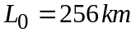 is the maximum size of the GATE region. represent dimensionless fractions. The smallest pixels over which rainfall intensities were estimated were 4 km², which corresponds to 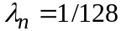, or,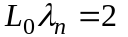km. The rainfall scans were taken every 15 minutes.
Suppose that rain rates in every pixel are statistically independent and identically distributed (IID). Then an event that no rain falls in a pixel is equivalent to no rain in each of the four pixels that comprise the pixel. By the IID property, the probability of no rainfall region is equivalent to the event of no rainfall in each of the four pixels. It can be written as
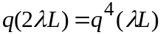 (26.1)

This is a similar to the functional equation, 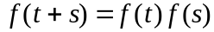, which was introduced in Lecture 7. The solution of Eq. (26.1) under general conditions of continuity is exponential,
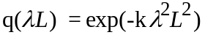 (26.2)
Expanding the exponential term in an infinite series and keeping the first term for small λL, Eq. (26.2) may be approximated as,
(26.3)
Over and Gupta (1994) tested the prediction given by Eq. (26.3) as a null hypothesis for GATE phase I and II data sets. It is called fractional wetted area (FWA) analysis. The procedure was to aggregate spatial rainfall into pixels of length and count the number of pixels that contained positive rainfall intensity. The total number of pixels is given by . The fraction of the area occupied by positive rainfall is , where, is the number of occupied pixels at scale . A plot of versus for different values of n=1,2,3,4,5,6 is shown in Fig. 26.1 (The symbol 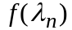 corresponds to FWA at scale in Over and
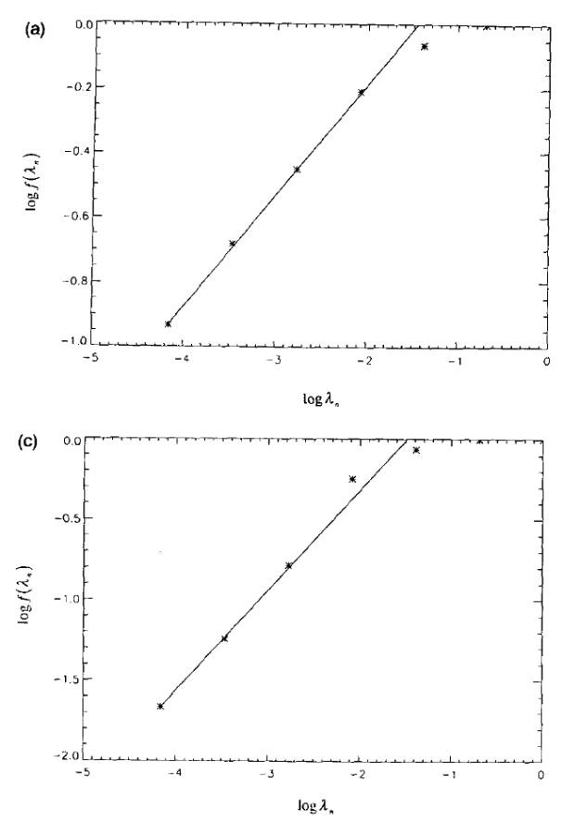

Figure 26.1 Scaling of fractional rainy areas from GATE phase I and II
(From Over and Gupta, 1994, Fig. 6a, 6c)

Gupta (1994, eq. 3.15)). The number of occupied pixels was fitted to a power law but with a different slope than 2 predicted by Eq. (26.3). Towards the upper end of the graph the break in scaling is due to saturation of rainfall. The last two points were omitted in calculating the slope. This means that the spatial scales that were analyzed ranged from 2 km to 64 km, and they exhibited a power law or scaling.
The presence of scaling with a slope quite different from 2 suggests that the IID assumption is not satisfied by data. In this connection, Gupta and Waymire (1993) showed that a spatial stochastic model of rainfall, called the random cascade model exhibits scaling in the FWA. The correlation structure of a random cascade model exhibits long-range dependence and violates the independence assumption among spatial rainfall intensities. The main point to note is that scaling in FWA is tied to the presence of long-range dependence in the correlation structure. As mentioned before, the random cascade theory is beyond the scope of this course. We will revisit this issue in Section 26.3 dealing with a physical basis of scaling in oceanic rainfall.
To extend the FWA analysis to a longer time scale than that of a single scan, Over and Gupta (1994) computed the slopes, s, from the FWA analyses for multiple scans. They also computed the mean and maximum rainfall for each scan, denoted by 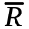 and 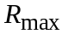 respectively, and observed that,

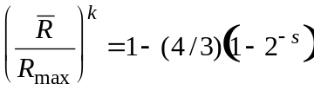 (26.4)

The empirical parameter k was estimated to be 0.24 and 0.25 respectively for the two GATE phases. This empirical relationship is finding important applications. The first example is given in tests of a space-time model of daily rainfall in southwestern Australia based in non-homogeneous random cascades (Jothiyangakoon et al., 2000).
Can the FWA analysis and other empirical relationship such as Eq. (26.4) be understood from a physical theory of rainfall? It requires a link between statistical and dynamical elements of rainfall as explained below.

26.2 Concepts from the Dynamics and Thermodynamics of Convective Rainfall
A key question in hydrology since a long time has been to understand the observed statistical variability of space-time rainfall on the basis of dynamical and thermodynamic processes that produce rainfall. This is a very difficult question and not much progress has been made towards answering it in the last forty years. It is well known that different types of storms ranging from convective thunderstorms to extra-tropical cyclonic storms produce rainfall. Meteorologists generally divide rainfall into two categories based on the physical process involved in its generation. These are, (i) stratiform rainfall that is generated slowly through evaporative processes and (ii) convective rainfall that is developed through violent vertical motions in the atmosphere. Convective rainfall fields produced by thunderstorms tend to be highly variable compared to stratiform rain fields. Convective rainfall is mostly responsible for producing floods.
To understand convective rainfall, several concepts need to be defined. First, is the concept of the Level of Neutral Buoyancy (LNB) - it refers to the height at which a packet of rising air comes to rest. This is easily defined physically through Bernoulli's equation. It is generally a point high in elevation in the atmosphere. If you've been in a plane and looked at the cloud ceiling, you have seen it. The second concept is the Level of Free Convection (LFC). It is the key to understanding convective rainfall. Packets of air tend to be stable close to the ground, since the air around them is relatively moist and warm. However, if such a packet suddenly rises to a few thousand meters above the ground, it is no longer stable. This is due to the fact that it is much warmer and moister, and therefore less dense than its surroundings (recall the equation of state for ideal gases which states that at a fixed pressure, P, the density is inversely proportional to temperature, T). It happens that in the atmosphere, there is generally a fairly sharp height at which a packet of air close to the ground is no longer stable. It is known as LFC. Packets of warm air close to the ground have, of course, a potential energy associated with them for their ascent. This energy is known as the Convective Available Potential Energy (CAPE). In addition, a certain amount of energy is required to rise to the LFC, a quantity known as the Convective Inhibition (CIN) (Emanuel, 1994). So in order for the packet to convert its potential, CAPE, into kinetic energy and rise to the LNB, something must "trigger" the packet by giving it enough energy to overcome the CIN. Such triggers typically occur when wind strikes some mass it cannot penetrate (for example, mountains, sharp density gradients or "fronts"), or when differential heating on the ground heats the air above it, thereby making the air less dense than its surroundings (for example, over small bodies of water). Once the CIN is overcome, the packet rises quickly. This situation is known as "conditional stability".
An analogy from physics of a ball on a hill is frequently used to understand conditional stability. If I have a round object on a convex surface, gravity will act on it such that the object will move towards the lowest point on the local surface, and in the absence of perturbations (eg. kicks to the ball, wind), the object will remain there. This makes it "stable”. However, if the surface has two unequal local minima and the object resides in the higher one, for large enough perturbations the object is no longer stably configured in the higher minimum, but will instead roll up and over the barrier between them and down to the lower point, where gravity makes it stable to all perturbations. It nicely describes the concept of conditional stability, especially if we let the lower minimum correspond to the LNB, the top of the barrier between the minima to the LFC, and the amount of energy we must kick the object with to get it over that barrier to the CIN. Then the energy the object acquires as it drops to the lower minimum from the barrier top corresponds nicely to CAPE. In fact, the only real difference here is that a packet of air rises to its stable configuration, whereas a ball drops to the lower minimum.
The process of condensation, which occurs as the packet rapidly ascends to its LNB, involves the releasing of latent heat to the environment, which further fuels the ascent, and the convergence of winds at the surface. Once aloft, moist air from the packet moves throughout the cloud, further condensing and sometimes freezing (in the upper reaches of a "deep" cloud). The drops that form begin to fall and coalesce into raindrops or snow, and eventually fall to the ground if they encounter no updrafts to bring them back to the cloud. Rainfall from convective storms usually brings with it masses of cold air from the cloud aloft, air that has descended so quickly it hasn't had time to warm to match its surroundings at the surface. As more and more rain falls, more air is brought down, forcing the formation of a spreading "cold pool" or "gust front" at the surface. These gust fronts are, of course, capable of developing even more convection as they move out along the surface and strike the warmer, moister surface winds.

26.3 Dynamical Origins of Scaling Statistics in Convective Oceanic Rainfall
Nordstrom and Gupta (2003) developed a dynamical model for understanding the statistics of tropical oceanic rainfall. It was an attempt to directly model rainfall and cloud dynamics. Nordstrom and Gupta (2003) illustrated in a preliminary manner how statistical scaling arises in oceanic convective rainfall, and how it can be interpreted in terms of physical parameters.
The dynamical model of oceanic convective rainfall includes two horizontal dimensions and is deterministic. The effect of the vertical dimension is parameterized by a 'characteristic time scale', which greatly simplifies the physics of rainfall in the model. However, the vertical dimension is nonlinearly coupled to the horizontal through the model equations. The phenomenology used in the model is a direct physical representation of the principle mechanisms that sustain convective activity over the tropical oceans, and relies upon the action of gust fronts. The model requires the existence of a cold pool as the initial condition, which represents a mass of air outflow from a prior storm. This air is dry, since the moisture it contained when it was aloft has condensed and fallen out. This mass is also supposed to be colder than its surroundings. Therefore, it must be denser than ambient air by the ideal gas law, which states that at a fixed pressure, P, the density is inversely proportional to temperature, T.
The model requires the specification of a constant velocity vector U, which represents the two-dimensional horizontal movement of a quantity of warm, moist air parallel to the surface. Both air masses are initially taken to exist stably in the region below LFC. The cold pool provides trigger conditions for packets of warm incident air to rise above the LFC till they reach LNB. In order to be pushed above the LFC, the incident wind deflects from the denser cold pool and acquires a vertical component to its motion by reinforcing the moderate density gradients, and punishing both the weak and strong ones, as shown in Fig. 26.2. The amount of energy required for a successful trigger is CIN, as introduced above. In the model the LNB is specified by a simple time-scale scheme, such that when clouds have developed past a certain threshold they rain out, replenishing the cold pool ground ward with more cold air from the outflow. The LFC is considered implicitly, and the CIN is represented phenomenological.
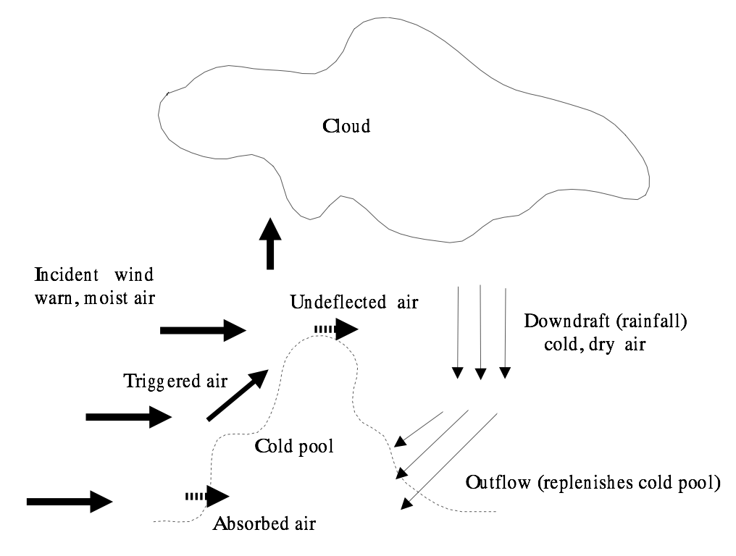
Figure 26.2 Schematic of phenomenology in Rainfall Convection used in Nordstrom and Gupta (2003)

Rainfall is assumed to follow the movement of air masses as a passive tracer for reasons of simplicity. The model equations are integrated numerically. The model is initialized with a randomly generated cold pool in the center of the model grid, and all other fields are initialized uniformly to 0. The calculated rainfall fields show as if it is the outcome from a stochastic process, but no statistical assumptions are made in the model. How is this possible that a purely deterministic model can exhibit statistical behavior? This is a very big question that lies at the very frontiers of physical, mathematical, geophysical and biological sciences. You can see from Fig. 26.3 that there is definite similarity between the output of the model and data. Both are highly variable and highly intermittent, and both appear to show this behavior on all scales.
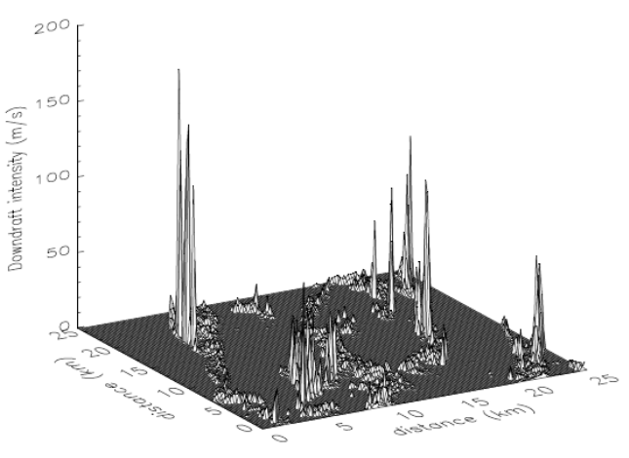
Figure 26.3 Sample of Model Output for Oceanic Rainfall
(Nordstrom and Gupta, 2003)

This model like many models is composed of grid points which are connected in a square cross-hatched pattern with a certain separation or resolution. This study chose to use a 200 m separation, though many of the radar studies it is compared to collected data on a 4 km grid. This means that to see the model data on the same resolution as the real data, blocks of 200 m resolution data are simply averaged into 4 km blocks, a process known as coarse graining. In this case we would be averaging square blocks of 20 grid points of model data on a side in order to compare it directly to the real data. But of course, the real data is collected from a process that didn't occur in 4 km blocks! The real data didn't even occur at a 200 m resolution. Rather, it occurred on microscopic scales (condensation), aggregated to millimeter scales (coalescence into raindrops), aggregated to scales of meters to hundreds of meters (downdrafts and fallout), aggregated to thousands of meters (thunderstorm cells), and so on. Thus, the outward manifestation of rain is the result of the "up scaling" of many processes, and there would appear to be no preferred level at which to view it. In this context, the concept of scaling becomes very interesting when applied to rainfall, especially since it would seem that the small-scale physical processes contribute to rainfall aggregation that affects the large-scale behavior over large distances. Avoiding the details, under such a situation we may expect to see self-similar behavior on different scales.
Self-similar behavior is characterized by the observation of power laws as explained before. The simplest sort of analysis one may perform to test for scaling in rainfall is the FWA analysis. Fig.26.4 shows scaling plot of model data from parameter b₁, which determines CIN. As b₁ becomes larger, CIN increases. For the value of b₁>3.419, rainfall is observed to be a transient phenomenon, and for b₁<3.419, rainfall persists. To investigate this issue in our rainfall model, FWA analysis for a parameter b₁=3.41 is shown in Fig. 26.4. Scaling is observed over spatial scales larger than two orders of magnitude. This suggests long-range correlations in spatial rainfall. For example, Gupta and Waymire (1993) showed the
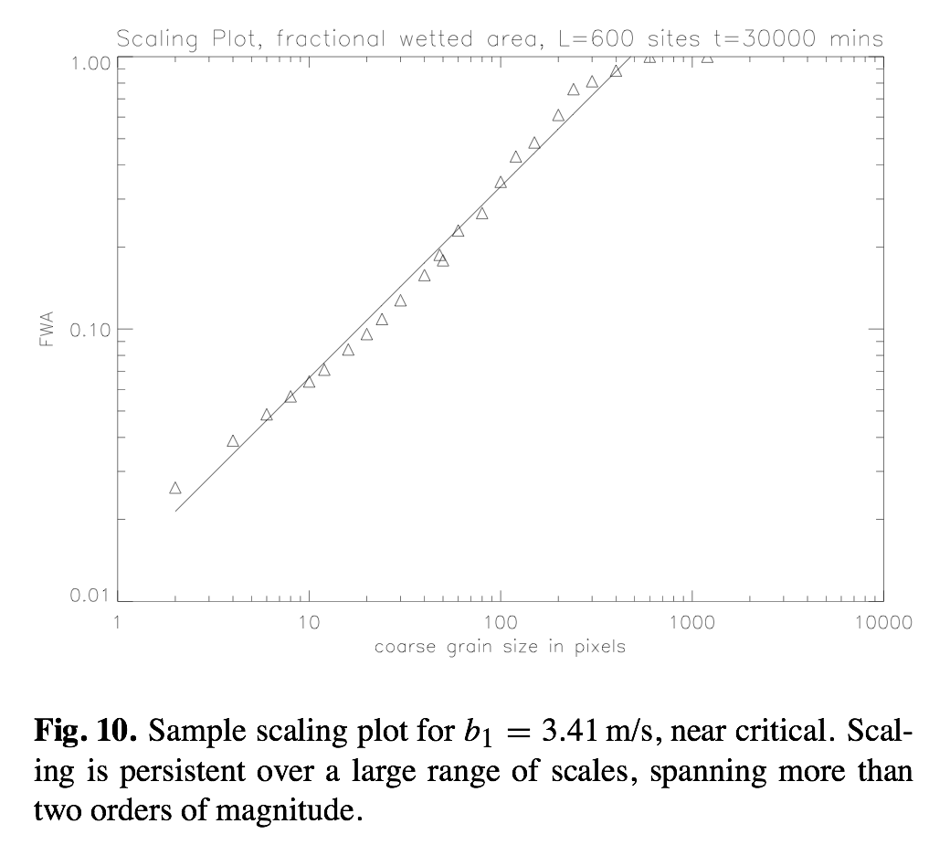
Figure 26.4 Fractional Wetted Area Analysis (Nordstrom and Gupta, 2003, Fig. 10)

presence of scaling in FWA analysis using the random cascade model that is well known to have long-range spatial correlations. However, an explanation of this feature is beyond the scope of this course. Further investigations of the Nordstrom-Gupta model are in their infancy, and it has a long way to go to fully represent convective processes over land in both tropical and extra-tropical regions. Nevertheless, it represents a new approach to the problem of understanding scaling statistics from physics of rainfall, and as such may well serve as a basis for the development of future statistical rainfall models in space and time.

References
Emanuel, K. Atmospheric Convection. Oxford, 1994.

Gupta, V. K. and E. C. Waymire. A Statistical Analysis of Mesoscale Rainfall as a Random Cascade. J. Appl. Meteo., 32(2): 251-267, 1993.

Kedem, B., and L. S. Chiu. Are rain-rate processes self-similar? Water Resour. Res., 23(10): 1816-1818, 1987.

Jothityangkoon, C, M Sivapalan, and N. R. Viney. Tests of a space-time model of daily rainfall in southwestern Australia based on nonhomogeneous random cascades. Water Resour. Res., 36(1): 267-284, 2000.

Nordstrom, K. and V. K. Gupta. Scaling statistics emergent in a nonlinear physical model of oceanic convective rainfall. Nonlinear Proc. Geophy. 10: 531-543, 2003.

Over, S, and V. K. Gupta. Statistical Analysis of Mesoscale Rainfall: Dependence of a Random Cascade Generator on Large-Scale Forcing. J. Appl. Meteor., 33(12): 1526-1542, 1994.

